**Practical 10 – WD – A well formed web page**

Download the zip folder of files for Practical 10 from Moodle. This file contains a number of image files, pdf files and a text file. You are required to create a well formed webpage (named **glenbarrow.html**) that appears similar to the screen shots shown in **Figure 1** and **Figure 2**. **Figure 1** shows how your page should look after completing Activity 1 **WITHOUT** style rules. **Figure 2** shows how your page should look after completing Activity 2 with style rules applied.

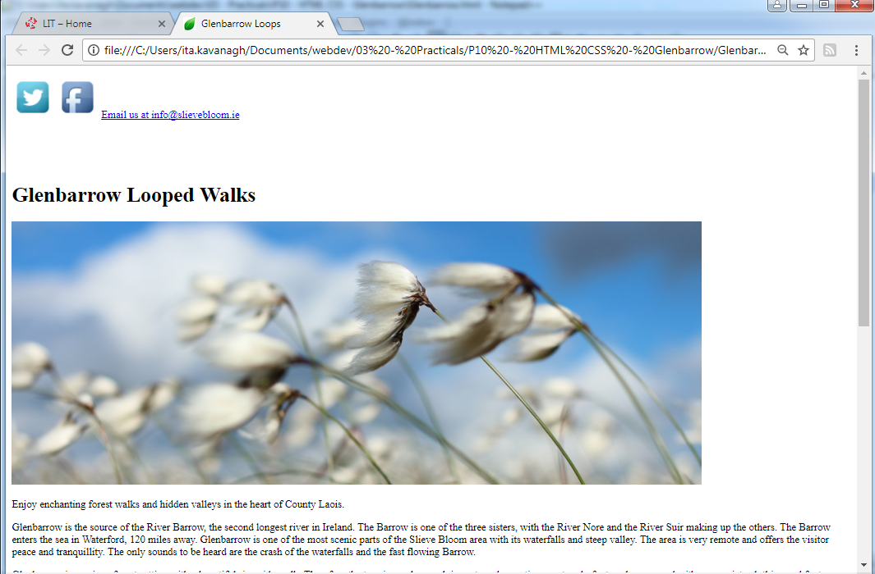

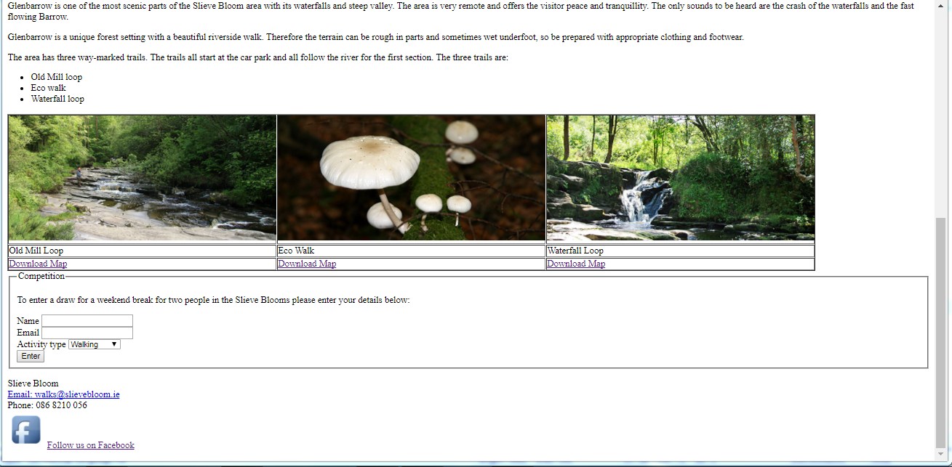

**Figure 1**: glenbarrow.html without style rules

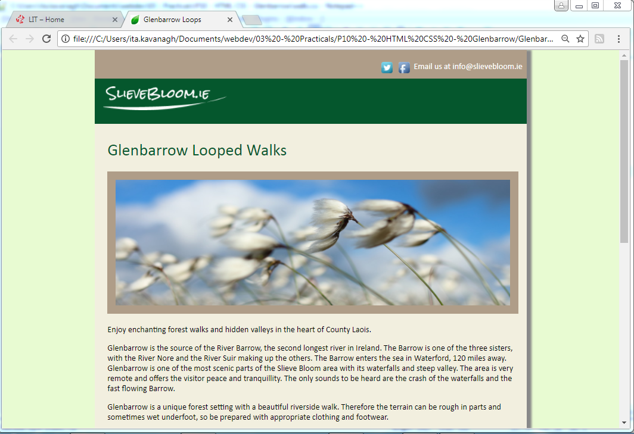

h1

div #contact

div #logo

main

header

div #container with width 70% and background color # F2EFDF

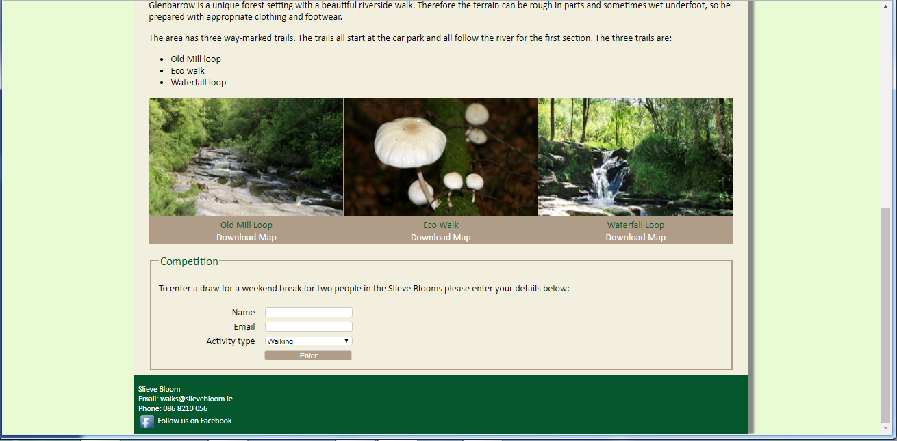

footer

ul

table with 3 rows and 3 columns

form

**Figure 2**: glenbarrow.html with style rules

**Activity 1 - Content**

Create a HTML page named **glenbarrow.html** with the following structural components:

1. A "wrapper" div with an id **container** that contains ALL the other html body elements.
2. A **header** element that contains two div elements:
   1. A div element with an id **contact** that contains 3 hyperlinks:
      1. An image element that links to <http://www.twitter.com/Walkslievebloom>  
         Use the **twitter.png** image file provided. Your hyperlink should open in a separate tab, i.e. target="_blank"
      2. An image element that links to <https://www.facebook.com/slievebloomoutdoors/>   
         Use the **facebook.png** image file provided. Your hyperlink should open in a separate tab.
      3. A text hyperlink "Email us at [info@slievebloom.ie](mailto:info@slievebloom.ie)" that opens the default mail program with an email addressed to **info@slievebloom.ie**
   2. A div element with an id **logo** that contains
      1. An img hyperlink element that links to <http://www.slievebloom.ie/>. Use the **logo.png** image file provided. Your hyperlink should open in a separate tab.
3. A **main** element that contains:
   1. A level 1 heading element with the text "Glenbarrow Looped Walks" .
   2. An image using **bogcotton.jpg** as the image source.
   3. Four paragraphs of text (all text available in **glenbarrow.txt**).
   4. An unordered list listing the three Glenbarrow trails.
   5. A table with 3 rows and 3 columns as shown in **Figure 3.** Note all the table elements are table data elements.
      1. Each cell in the first row contains an image. Use the image files provided glenbarrow_old_mill.jpg, glenbarrow_eco.jpg and glenbarrow_waterfall.jpg
      2. Each cell in the second row contains some text. Use the text provided "Old Mill Loop", "Eco Walk" and "Waterfall Loop"
      3. Each cell in the third row contains a text hyperlink that link to the relevant pdf file. Use the pdf files that are provided, i.e. glenbarrow_old_mill.pdf, glenbarrow_eco.pdf and glenbarrow_waterfall.pdf

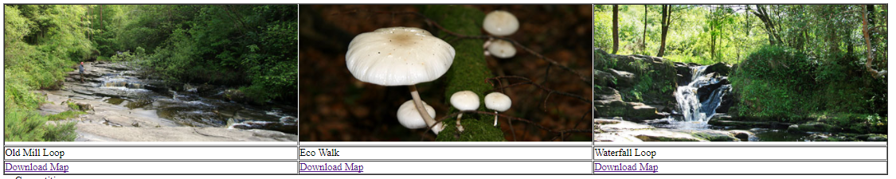

**Figure 3**

* 1. A **form** element with the following form elements:

1. A legend and fieldset.
2. A text input (with name attribute **name**) to get **Name.** Use explicit association.
3. A text input (with type attribute **email** andname attribute **email**) to get **Email.**
4. A menu to select **Activity type** (with name attribute **activity)** from one of five options Walking, Cycling, Angling, Equestrian, Golf (with value attributes **Walking**, **Cycling**, **Angling**, **Equestrian** and **Golf** respectively).
5. A submit button. When the user presses the submit button the form should be sent via the POST method to [**http://litstudentprojects.net/slievebloom.php**](http://litstudentprojects.net/slievebloom.php)
6. A **footer** element that contains:
   1. The text "Slieve Bloom"
   2. A text hyperlink "Email: [walks@slievebloom.ie](mailto:walks@slievebloom.ie)" that opens the default mail program with an email addressed to **walks@slievebloom.ie**
   3. The text "Slieve Bloom"
   4. Phone: 086 8210 056
   5. An image and text hyperlink that links to <https://www.facebook.com/slievebloomoutdoors/> . Use the **facebook.png** image file provided. Your hyperlink should open in a separate tab.

Your page should now resemble **Figure 1.**

**Activity 2 – Styling your Page (CSS)**

You will now style your page so that it resembles **Figure 2.**

Note: In Activity 1 (step 1) you should have surrounded the content of the body of the document with a pair of div tags. The id of this div should have been set to "**container**".

1. Create an external stylesheet named "**walk.css"** and add a link to this stylesheet in the head element of the **glenbarrow.html** file.

Create style rules for the following:

1. The **container** div should have a width of 70%, background colour # F2EFDF. Set the margin property to auto to centre the div on the page. The top and bottom margin should be 0px.
2. The font family for the **body** of the page should be set to Calibri and then the default sans serif font. Font size should be 1.1em. The background colour should be set to #e8fbd2.
3. The **contact** div should a height of 3 ems, a background colour of #AF9D88, padding top and bottom of 0.2 ems, padding left and right of 0.5em. Text should be aligned right and be white in colour.
4. Images in the **contact** div should have a height and width of 32px and be vertical aligned in the middle.
5. The **logo** div should a height of 5 ems, a background colour of # 05572d, padding top and bottom of 0.2 ems, padding left and right of 0.5em.
6. Images in the **logo** should float left and have a margin top and bottom of 0.7em and a margin left and right of 0.5em.
7. Set the padding for the **main** element to0.5 ems top and bottom and 1.5 ems left and right.
8. Images in the main element should have a width of 97%, a height of 15em and a 1em solid border with a border colour of #AF9D88
9. Heading one elements should have a colour #05572d and not be in bold, i.e. font-weight should be normal.
10. The **footer** element should have a background colour set to #05572d, text should be white and smaller. The height of the footer element should be 7 ems, margins should be 0 and padding should be set to 0.2 ems top and bottom and 0.5 ems left and right.
11. Images in the **footer** element should have a height and width of 32px, a 0 px border and be vertically aligned to the middle.

**Styling the table**

1. The table should have a solid border of 1px with colour #AF9D88. The text should be aligned to the centre. The background colour should be set to #AF9D88 and the border-collapse attribute set to collapse. Note: to provide space above and below the table set the top and bottom margin to 1 ems (the left and right margins should be 0 as the main element has a padding attribute set).
2. Table data elements will also have a solid 1px border with colour #AF9D88.
3. Images in the table should have a height and width of 100% and the border attribute should be set to none.
4. Set the colour of the table data elements in row 2 to #05572d. You could assign them an id or a class or use the CSS pseudo elements:  
    table tr:nth-child(2){color: #05572d;}

**Styling the form**

1. Labels should have a width of 10em and a right margin of 1em to separate them from the input text fields. They should float to the left and the text should be aligned to the right.
2. The text colour of the legend should be set to #05572d. It should have a font-size of 1.2em.
3. The fieldset should have a solid, 3px wide, border set to # AF9D88. The line height should be set to 1.5 ems.
4. Set the width of the input elements and the menu (select element) to 12 ems, display as an inline-block with a solid 1px #ccc border. To allow the box sizing to include the border set the box-sizing attribute, e.g.   
    box-sizing: border-box;

See <https://www.w3schools.com/cssref/css3_pr_box-sizing.asp> for more detail

1. Write a CSS rule to position the submit button.

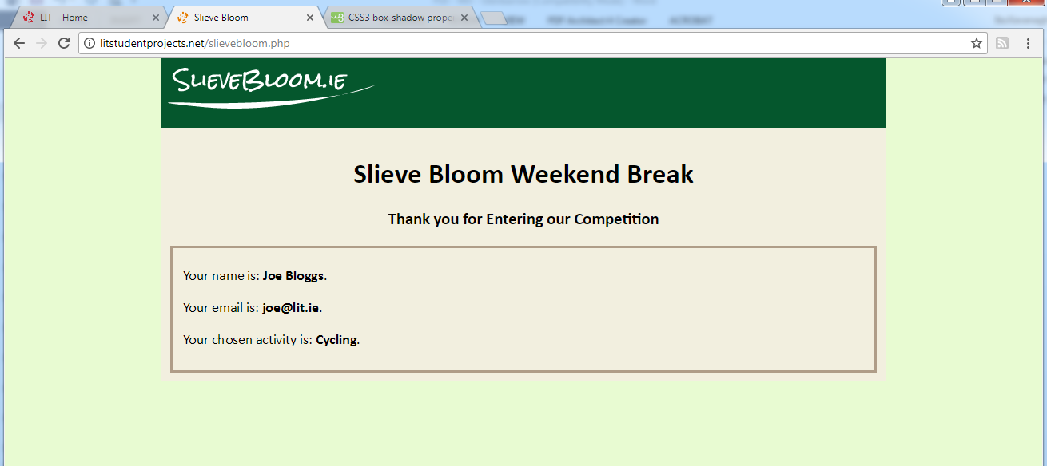

**Figure 4:** Competition Entry Response Form

**Additional Styling Information:**

1. Add a favicon to gelnbarrow.html using the leaf favicon provided.
2. All **hyperlinks** should appear in white and not be underlined. The CSS to do this is:  
    a:link , a:visited{  
    text-decoration: none;  
    color: white;  
    }  
   See CSS Lecture 3 for more detail.
3. To get a **shadow effect** on the **container** div you can set the box-shadow attribute to 10px 0px 5px #888888; Note: the box-shadow syntax:  
   box-shadow: [horizontal offset] [vertical offset] [blur radius] [optional spread radius] [color];  
   For more detail see: <https://www.w3schools.com/cssref/css3_pr_box-shadow.asp>
4. Note: to remove the default page margins that some browsers insert you can set the page margins to 0px.
5. To add rounded borders to a form element set the border-radius, e.g.   
    input, select{ border-radius: 4px; } /*adds rounded borders */

**NB: Upload your work at the end of todays practical, i.e. 4pm 23/11/17 AND upload again for Tuesday 28/11/17 6pm. (3 uploads allowed)**